

**Step 2. Compelling Content Creator**

**Exercise 2.5: Social Media 101**

**QUICK Guide to the Top Social Platforms:**



**FACEBOOK**

#1 global social media network

Easy to monitor a page and report / block / hide content

Easy to amend existing posts

Need to create a business page, don’t use your personal page

Ensure you include all your contact information

You are ranked on how quickly you respond online

Able to post up a variety of valuable content – text, imagery, videos etc.

Can also utilise highly targeted adverts or boosted posts to access certain audiences in your area

Highly influential for business positioning and ability to promote services

**TWITTER**

Main selling points: SPEED and BREVITY (140 characters)

Cannot edit tweets

Once something is retweeted by another user, it is in the public domain   
and cannot be removed

Good for building your profile and connecting with influencers, bloggers, media and certain consumer audiences

Retweeting and sharing others’ content is a great way to build engagement

Hashtag function highly important – allows people to search, follow and group relevant topics / conversations

Able to engage and ask questions of followers – online polls

**INSTAGRAM**

Photo-sharing site - entirely based on visual elements   
(images and video)

Can post your own photos and repost those of others which your followers may find interesting

Audience tends to be younger – frequently used by celebrities

Hashtags used post subjects and provide links to related posts with the same hashtag

Almost entirely used on mobile devices – limited web functionality

Photos / videos need to be high quality – demand for unusual or artistic elements

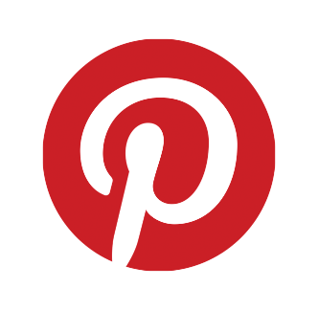**PINTEREST**

Digital ‘bulletin’ board format – you ‘pin’ digital content you like

Can create private or public boards, grouping products /   
companies in similar categories

Useful for product-based businesses to promote sales / encourage usage

Again, visual channel – images and videos

Can be limited by the amount of new content you have available to post

Public boards need to be organised and easy to find (using hashtags)

**LINKEDIN**

Primarily used for professional networking / B2B relationships

Includes Company Pages as well as personal pages

Allows for sharing of various content types between followers and/or the public

Includes groups can be a good way of finding new connections / partners

Some groups are private or members only and you must be assessed before being allowed in

Discussions / questions and events can then be posted about

**YOUTUBE**

Video-sharing site owned by Google

Second-largest search engine in the world – highly important for your SEO and visibility

Images and videos used on website attract more users and longer attention

Make sure you create a channel for your clinic with good quality artwork

Useful for posting informative videos about you, the clinic, top procedures and treatments

Builds engagement and trust before even walking in the door!

**G+**

Not really a ‘social’ platform – more about SEO value

Often used as a tool to boost SEO ranking and visibility

Replicating posts from your blog or other platforms

You need to create a page for your clinic and optimise with as much information as possible

Allows you to share information to specific audiences by use of ‘circles’ – types of groups/networks

Hashtags can make posts more searchable

**5 STEPS TO GETTING STARTED ON SOCIAL MEDIA**

1. Create accounts across all key social media channels to occupy the space – ensure consistency of handles / usernames
2. Identify which channels you are going to prioritise / be active on (consider patient database / target demographics)
3. Start by following other relevant accounts to build up your own followers, engaging with their posts and asking them to share your content, where appropriate
4. Create a monthly social media posting plan in line with your marketing calendar – where possible input the whole schedule into an automated social posting tool such as Hootsuite
   1. Make sure you’ve got the 75 / 25 ratio right!
5. Start engaging with your followers and those you follow – repost/retweet, comment, share, ask questions, respond to your audiences

**WHAT to Post & WHEN**

Create tailored posts across the different channels you’re prioritising – depending on the platform, you will need a different ratio of text vs imagery etc.

Posts contents could include:

* Quotes
* Tips
* Behind the scenes photos
* Patient testimonials and success stories
* Patient before & afters (Consent!)
* Product photos and links
* Good content from others
* Your Blog post links
* Offers and discounts
* Events information
* New team members
* Videos
* Interesting facts
* Seasonal greetings / facts
* Sneak peak photos
* Old popular content
* Recommendations
* Industry news in the media

When it comes to FREQUENCY of posting – here’s a topline guide:

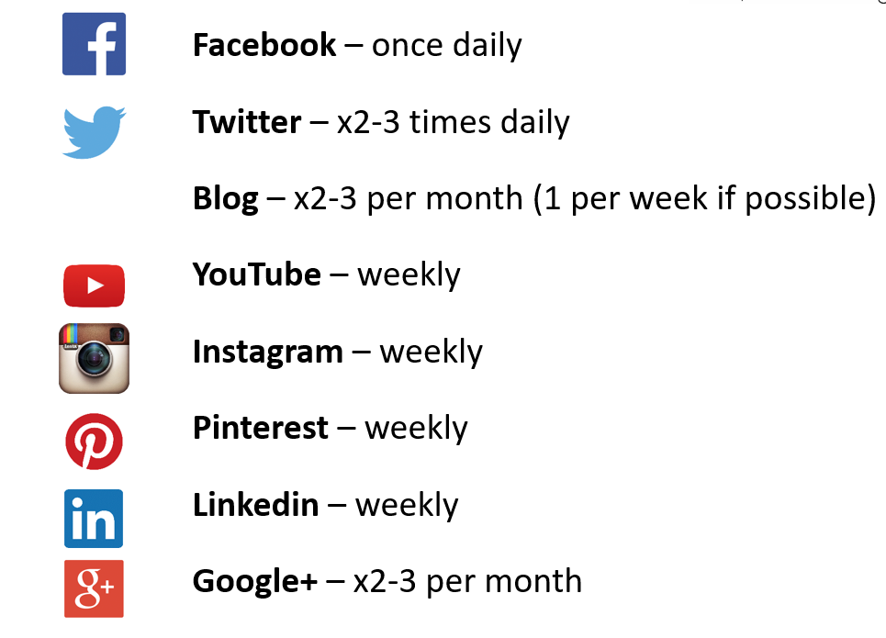

**DON’T FORGET!** Make sure you put your social media account icons on ALL your materials, to maximise the chances of engagement with your audiences!

**Privacy & Legal – Key points**

* Be very aware of patient privacy and confidentiality
  + Never disclose personal details and maintain a professional distance
  + Always ensure images / videos etc are used with consent
  + Never discuss medical care online
* Beware the blurred line between personal and professional! Personal activities on social media can have ramifications for your business
* Check with professional organisation and insurance providers about latest guidelines
* You are still responsible for what social media suppliers post on your behalf
* Create a social media policy for staff to give clarity on expectations – see your **downloadable template in the member’s area**

**WELL DONE! You’ve completed Module 2.5 of the Compelling Content Creator!**